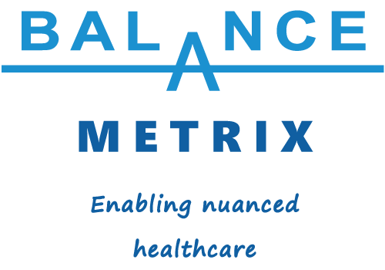
Add Extra Balance Assessment Capability to Your Practice
26 March 2026

What follows is some information for physiotherapy and exercise physiology clinicians considering adopting Balance Mat postural sway measurements for their practices. It answers the what, why and how questions and is designed to be read in conjunction with a free customisable information flyer designed to help you attract prospective new clients.

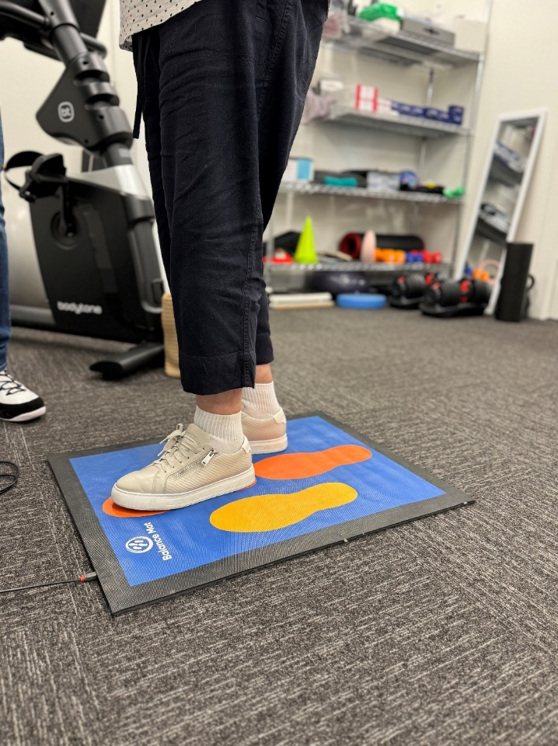
You’re already balance experts, right!? Now you can enhance that reputation and the collective skillset of yourself and your team members to help older clients improve their balance and reduce their falls risk. How? By adding objective postural sway metrics to your balance assessments. By purchasing or taking out a monthly or annual subscription to our TGA-approved, patented, Australian, university-validated Balance Mat technology (pictured, right and on our website balancemetrix.com.au. The Balance Mat from Balance Metrix Pty Ltd is a computerised floor mat that displays any movement on the mat on a connected desktop or laptop computer and enables a PDF printout of individuals’ graphs and scores and an aggregate graphs of entire cohorts. By giving your physiotherapy and exercise physiology team members something to crow about! Individually and for your brand. It’s an ideal way to position the brand as the Balance Experts.
And, of course, by providing you and your team with another clinical tool that can be used to gain objective measurements of postural sway in five well-known balance testing positions – normal, semi tandem, tandem, left foot, right foot. You can see the value this could bring to your clinic when you consider testing, treating and re-testing your physiotherapy and exercise physiology clients. It will not only show how well the physiotherapy treatment or exercise therapy is working but it will also give clients an extra goal to work towards, meaning that as their strength and balance increases the numbers on the Balance Mat results will decrease. It’s going to be their challenge to get those numbers down over time. Especially if they’re working in a group. We often find that people like to compete with each other on who’s got the best balance score.
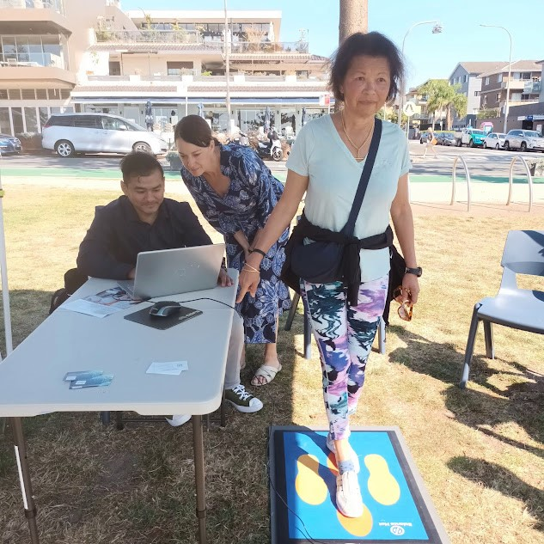
And as a marketing tool to draw in extra clients – whether they be individual community members or residential aged care providers at community or ageing-related events. One event Balance Metrix Pty Ltd supported is pictured below – World Clinical Exercise Physiology Day at Dee Why Beach – where we joined ten accredited exercise physiologists to promote the benefits of exercise therapy. It was an opportunity for us to showcase three of the main advantages of Balance Mat technology over other balance assessment tools – its user-friendliness, portability and ability to operate via a fully charged laptop without the need to plug it into an electricity source. This really demonstrated how versatile the Balance Mat is as a marketing tool. We’ve also had it operating in shopping centres, doctors’ surgeries, retirement villages and residential aged care homes. In the photograph Balance Mat Pty Ltd staffer Abishek Sthrestha is testing a woman’s balance in the tandem stance while Dr Sophie Scamps MP looks at the graph and score on the screen.
One of our partners – Council on the Ageing ACT (COTA ACT) – is currently charging prospective Strength for Life 50+ exercise class clients $40 as part of their initial balance and falls risk safety assessment. Another one of our partners – Highland Physios in Goulburn – is providing free Balance Mat tests for exercise class pre- and post-screening. One client – Hastings Physio & Health at Port Macquarie – is routinely using free Balance Mat tests in one-on-one exercise physiology appointments and a group balance class. You get the picture? You can charge or not charge for postural sway testing as part of your professional balance assessments, but whichever way you go, you can certainly build a lucrative and professionally beneficial program around it.

A Staged Implementation Plan For You
Over several years we have found that the best use of the Balance Mat technology is as part of a cohesive balance & falls prevention strategy for older people. If you have a clinic, you could base a campaign there. If you’re mobile, you could carry a Balance Mat with you wherever you go. We have mapped out a potential staged implementation plan for you below.
Step 1: Run A Dedicated Balance & Falls Prevention Campaign
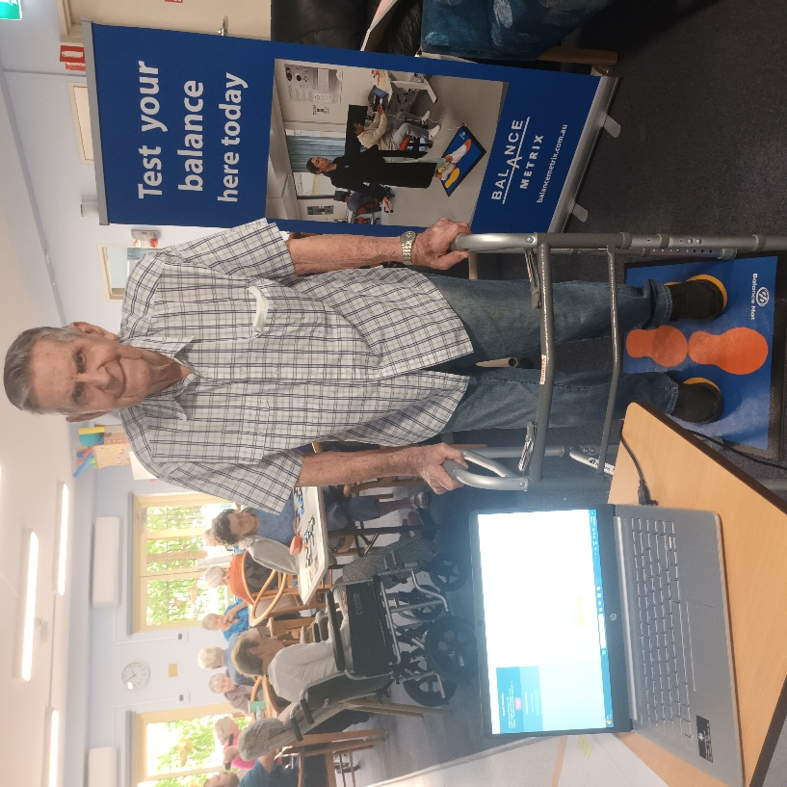
Start with one Balance Mat at one clinic and commit to a dedicated local balance – falls prevention marketing campaign. Ask some of your clients for their permission to use them as models to help promote your business, like this Garden Village Port Macquarie aged care resident below. Bill Tyrrell, aged 93, has given Balance Metrix permission to use his image and Balance Mat test results in our promotional material, saying, “Put me everywhere!” To learn more you can see Bill’s Balance Mat results on the Partners page of the Balance Metrix website.
If you’re already running exercise classes you could introduce Balance Mat testing into the normal routine – perhaps charging participants as an “optional extra” or including it free in one-on-one appointments. Bear in mind that each test on the Balance Mat only takes 20 seconds to conduct. There are five stances for you to pick and choose. For falls we recommend doing at least the normal and semi tandem tests. Most people test as having higher postural sway in semi tandem than in the normal stance but for people with peripheral neuropathy caused by Diabetes type 2 the opposite is the case (meaning they have higher sway in the normal stance). Depending on the person’s balance stability you could try tandem stance too. And for people with left leg – right leg asymmetry due to ankle, leg or hip injury, the left foot and right foot stances will give you and the client clarity on what you need to work on.
Once you have your photo / video content then you can use our customisable information to create your own marketing campaign to sell your services in the areas of balance assessment, falls risk mitigation, physiotherapy and exercise therapy. We would share your content on our website, email newsletter and social media accounts like we do for other Balance Mat users and Balance Metrix allied health partners in our Better Balance Initiative.
In addition, our Assistant Manager Raelee Pietrzak has started interviewing our partners for short-form reels to be posted on social media. We would be happy to feature you at no extra cost.
Step 2: Have Laptop, Will Travel!
Progressively add the Balance Mat to all your team members’ portable tool kits. By doing so you will be making an investment in your people’s ability to stay abreast of the latest, most versatile, most portable, quickest balance testing method ever invented!
Step 3: Cement Your Brand’s Reputation as the Balance Experts in Your Area
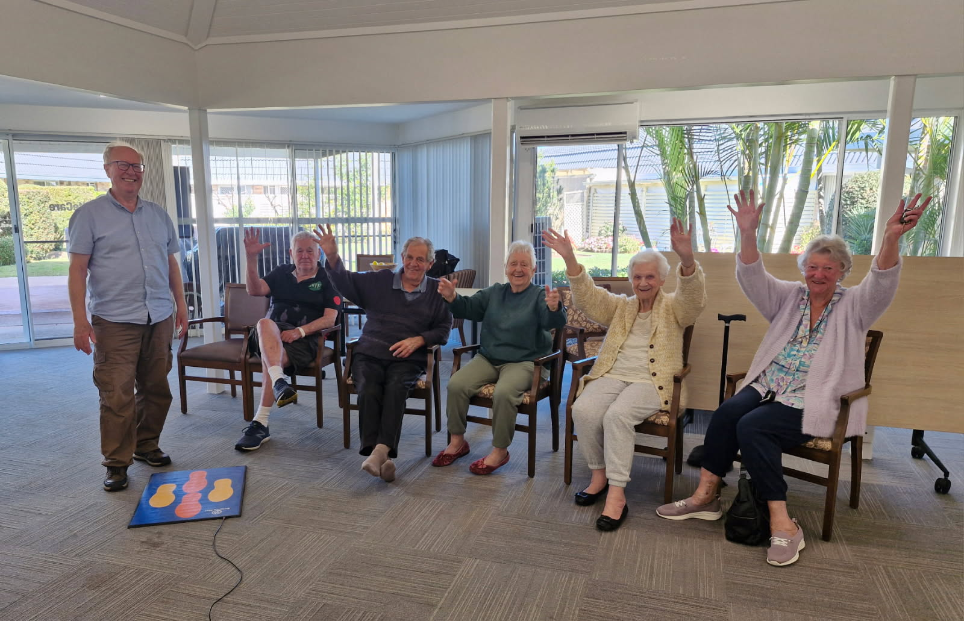
Work with local doctors to create balance-related cross-referral pathways. Distribute the marketing collateral you’ve made in Step 1 while you’re doing this. Give free demonstrations with five patients to show the doctors how the Balance Mat tests work and what the results mean (basically, people fall into low, medium or high postural sway categories and there are different protocols for each case).
Add a dedicated Balance & Falls Prevention page and booking form on your website and use a social media campaign to drive prospective new clients there. Also tell the existing clients on your mailing list about this extra special new balance assessment capability you now possess.
Showcase the Balance Mat technology at local and national ageing related events. Give conference papers on your results. Advertise your balance expertise and results in relevant publications like Australian Ageing Agenda or local newspapers, magazines and newsletters. Use your results to apply for local, state or federal government grants in partnership with Balance Metrix Pty Ltd.
Augment your brand by advertising your expertise and results in the Australian Physiotherapy Association (APA) and Exercise & Sports Science Australia (ESSA) literature. Participate in a model project in a residential aged care facility or community centre as a partner in our Better Balance Initiative (BBI). This Initiative seeks to help older people improve their balance ability and reduce their falls risk no matter where they live, as the happy folk pictured above at a Port Macquarie residential aged care home delighted in showing Balance Mat inventor Ian Bergman (pictured at left) after he tested their balance. You could consider sponsoring the BBI. These are just some of the actions you could take as part of a small- or large-scale, staged implementation plan if you decide to go ahead.

Your Investment
You’ll be surprised at how little a Multimetric Balance Mat investment is, especially when you consider the big benefits you will potentially receive in terms of:
- Reputation building
- Skills development
- Revenue generation.
You can get started from only $198 incl. GST, with a free trial during the first month, dropping to $51.15 incl. GST per month ongoing, with no lock-in contract and free delivery.

Be Part of the “Quiet Revolution”
Healthy ageing leader Dr Tim Henwood, principal consultant at AgeFIT Solutions, has described the positive ageing and #strengthspan movement as a “quiet revolution” that is set to sweep across the Australian healthcare landscape. We agree. If you are interested in helping this timely revolution become a little larger and louder, then we’d love to hear from you.

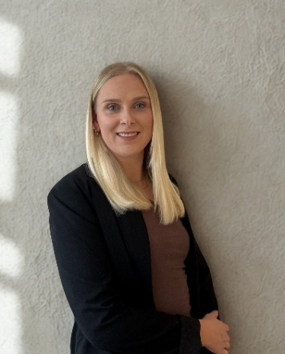
Contact Balance Metrix Assistant Manager Raelee Pietrzak
to start the purchase or subscription
and on-boarding process today.

Mob. 0436 120 093 or email raelee@balancemetrix.com.au

